JULIAN ZVIDZAI R227496F

A1

(a) Transition Diagram and State Classification
The transition matrix P for this 5-state Markov chain defines the movement between states.
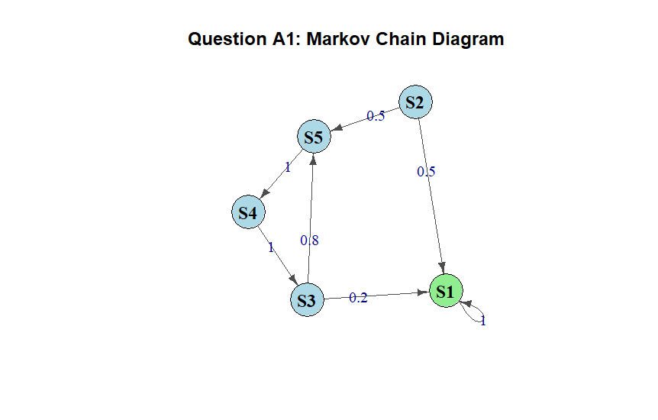 State Classification:
- Recurrent/Absorbing State: 1 and 2
- Transient Classes: {S2} and {S3, S4, S5}. These states are transient because there is a non-zero probability of leaving them and eventually entering the absorbing state S1, from which return is impossible.
- Irreducibility: The Markov chain is not irreducible because it contains an absorbing state and multiple communication classes.
- Periodicity: The absorbing state S1 is aperiodic (period 1). The transient loop {S3 → S5 → S4 → S3} has a period of 3, but this does not affect the long-run stability of the entire chain due to absorption.

(b) Trajectory Simulations
Three trajectories were simulated for 15 steps each:
- Trajectory 1: Stayed in S1 for the duration.
- Trajectory 2: Started at S3, moved through the transient loop (S3 → S5 → S4 → S3), and eventually transitioned to S1 where it became trapped.
- Trajectory 3: Reached S1 immediately and remained there.
These simulations confirm that regardless of the starting point, the system eventually gravitates toward the absorbing state S1.

(c) Steady-State Probabilities
The steady-state probability vector π was calculated as follows:
π=(1,0,0,0,0)
In the long run, the probability of the system being in state S1 is 100%. Since the chain is not irreducible, it is not ergodic.

(d) Unconditional Probabilities and Convergence
Starting with an initial distribution of P(0) = [0.2, 0.2, 0.2, 0.2, 0.2], probabilities were tracked over 50 steps.
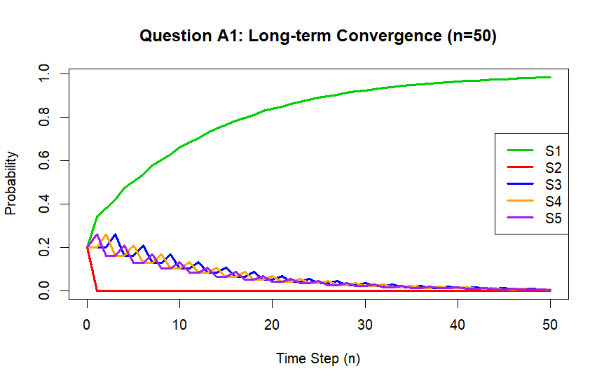

- Speed of Absorption: The system reaches near-total absorption by approximately step 20.
- Behavior at n=50: The probabilities for S2, S3, S4, and S5 decay to zero, while S1 flattens converges towards 1.0.
this is because state one is absorbing and nearly absorbs everything
state two is only absorbing so it quickly looses everything at step one

Question A2: 7-State Markov Chain Analysis

(a) Transition Diagram and State Classification
The 7-state Markov chain is defined by the following transition probability matrix P:
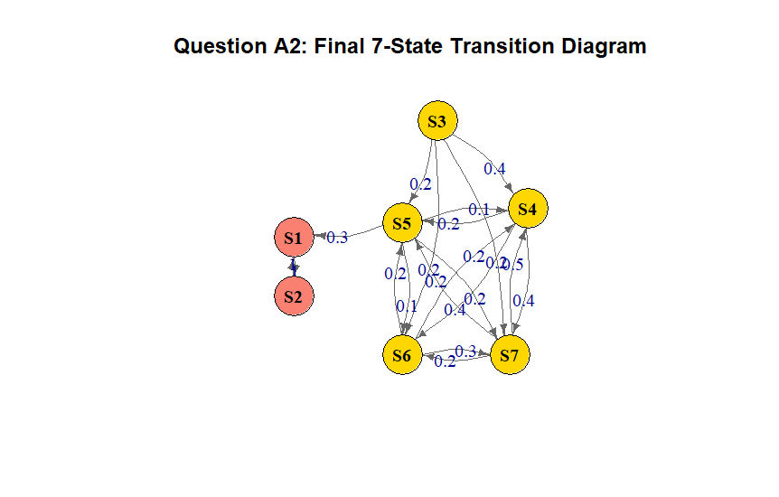
- Recurrent Class: {S1, S2}. Once the system enters this class, it oscillates between them indefinitely.
- Transient Classes: {S3} (initial entry point) and the group {S4, S5, S6, S7}.
- Absorbing States: None.
- Reflecting Behavior: S1 and S2 are reflecting states; they "bounce" the process back and forth with probability 1.0.

(b) Periodicity
- Recurrent Class Period: The class {S1, S2} has a period of 2. Returns to S1 only occur in even steps.
- Chain Periodicity: While software might return 0 for the entire chain due to non-irreducibility, the recurrent states are strictly periodic.

(c) Trajectory Simulations
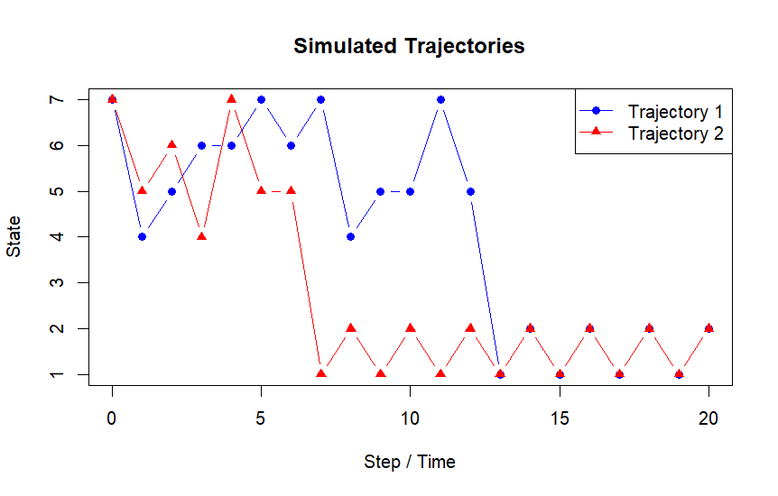 Early steps fluctuate between S3–S7. Eventually, the process exits at state S5 and enters the S1/S2 loop, creating a zigzag pattern.

(d) Limiting Probabilities and Ergodicity
The stationary distribution π was calculated as:
State | S1 | S2 | S3 | S4 | S5 | S6 | S7
Probability | 0.5 | 0.5 | 0 | 0 | 0 | 0 | 0
Ergodicity: The chain is not ergodic. It fails both criteria: it is not irreducible and it is periodic.

Question A3: Traffic Simulation Analysis

Part (a): Analytical Calculation at 6 PM
π(6PM) = π0 × (P_1)^9 × (P_2)^6.
Analytical Results:
- Light (State 1): 1.48%
- Heavy (State 2): 13.26%
- Jammed (State 3): 85.26%

Part (b): distribution evolution plot
Based on 10,000 independent trajectories:
Simulated Results at 6 PM:
Traffic State | Analytical Result | Simulated Result (10k runs)
Light (State 1) | 1.48% | 1.36%
Heavy (State 2) | 13.26% | 13.15%
Jammed (State 3) | 85.26% | 85.49%

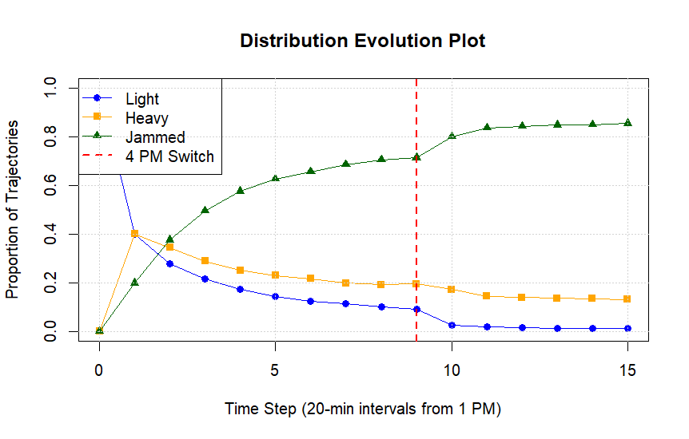
The simulated proportions closely converge with the analytical probabilities, confirming the Law of Large Numbers. The system shows a clear progression toward heavy congestion as time advances.

